
National University of Technology

Machine Learning Lab- CS3504

LAB Submitted to:

Lec.Hajra Ahmad

Submitted By:
Muhammad Abdullah

Reg. No: F22607010
Batch: Fall AI 2022
Lab : 04
Q.NO.1:
# Import necessary libraries
import numpy as np
import pandas as pd
from sklearn.datasets import load_iris
from sklearn.model_selection import StratifiedKFold
from sklearn.naive_bayes import GaussianNB
from sklearn.metrics import accuracy_score, classification_report, confusion_matrix
import matplotlib.pyplot as plt
import seaborn as sns

# Loading the Iris dataset
iris = load_iris()
X = iris.data
y = iris.target
class_names = iris.target_names

# Spliting the dataset using StratifiedKFold
skf = StratifiedKFold(n_splits=5, shuffle=True, random_state=42)

# Initialize Gaussian Naive Bayes
gnb = GaussianNB()

# Storing results
accuracies = []
conf_matrices = []

# Cross-validation loop
for train_index, test_index in skf.split(X, y):
X_train, X_test = X[train_index], X[test_index]
y_train, y_test = y[train_index], y[test_index]

# Training the Naive Bayes model
gnb.fit(X_train, y_train)

# Making predictions
y_pred = gnb.predict(X_test)

# Evaluating the model
accuracy = accuracy_score(y_test, y_pred)
accuracies.append(accuracy)

# Storing trices.append(confusion_matrix(y_test, y_pred))

# Print classification report for each fold
print(f"Classification Report for Fold:\n{classification_report(y_test, y_pred, target_names=class_names)}")

# Visualization of results

# Plot accuracies for each fold
plt.figure(figsize=(10, 5))
plt.plot(range(1, 6), accuracies, marker='o', color='b', label="Accuracy per Fold")
plt.title("Accuracy Across Folds")
plt.xlabel("Fold Number")
plt.ylabel("Accuracy")
plt.ylim(0.8, 1.0)
plt.grid(True)
plt.legend()
plt.show()

# Confusion Matrix for the last fold
plt.figure(figsize=(8, 6))
sns.heatmap(conf_matrices[-1], annot=True, fmt="d", cmap="Blues", xticklabels=class_names, yticklabels=class_names)
plt.title("Confusion Matrix for Last Fold")
plt.ylabel('Actual')
plt.xlabel('Predicted')
plt.show()

# Print average accuracy across folds
print(f"Average Accuracy: {np.mean(accuracies):.4f}")

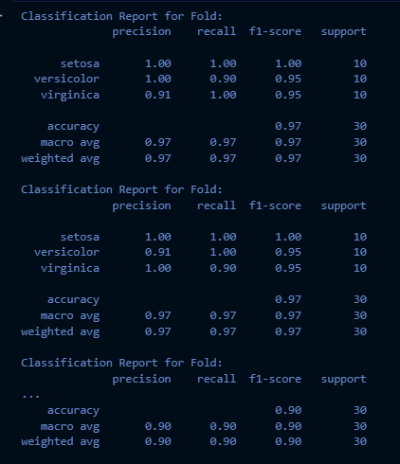

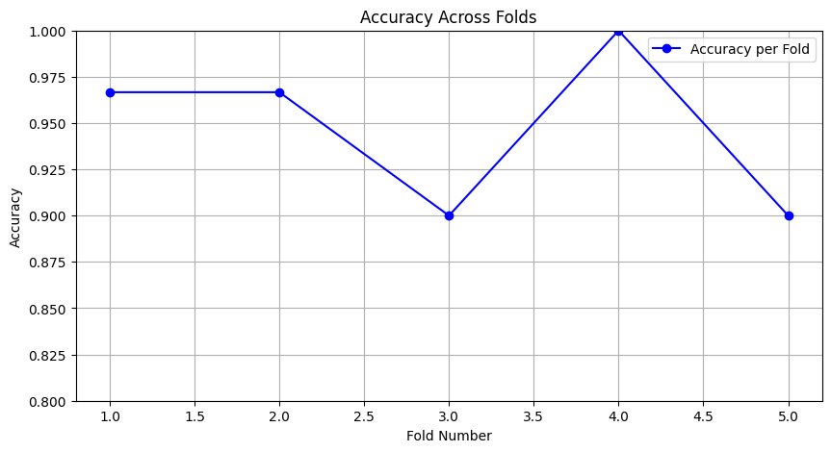
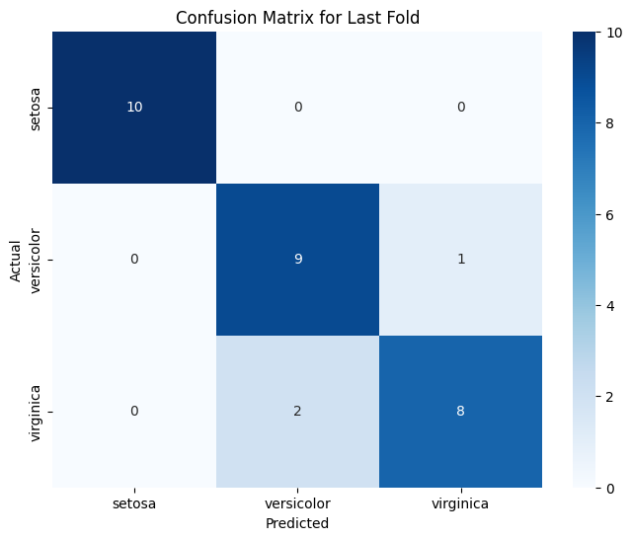

Average Accuracy: 0.9467

df['species'] = iris.target_names[iris.target]
sns.pairplot(df, hue='species', diag_kind='kde')
plt.show()

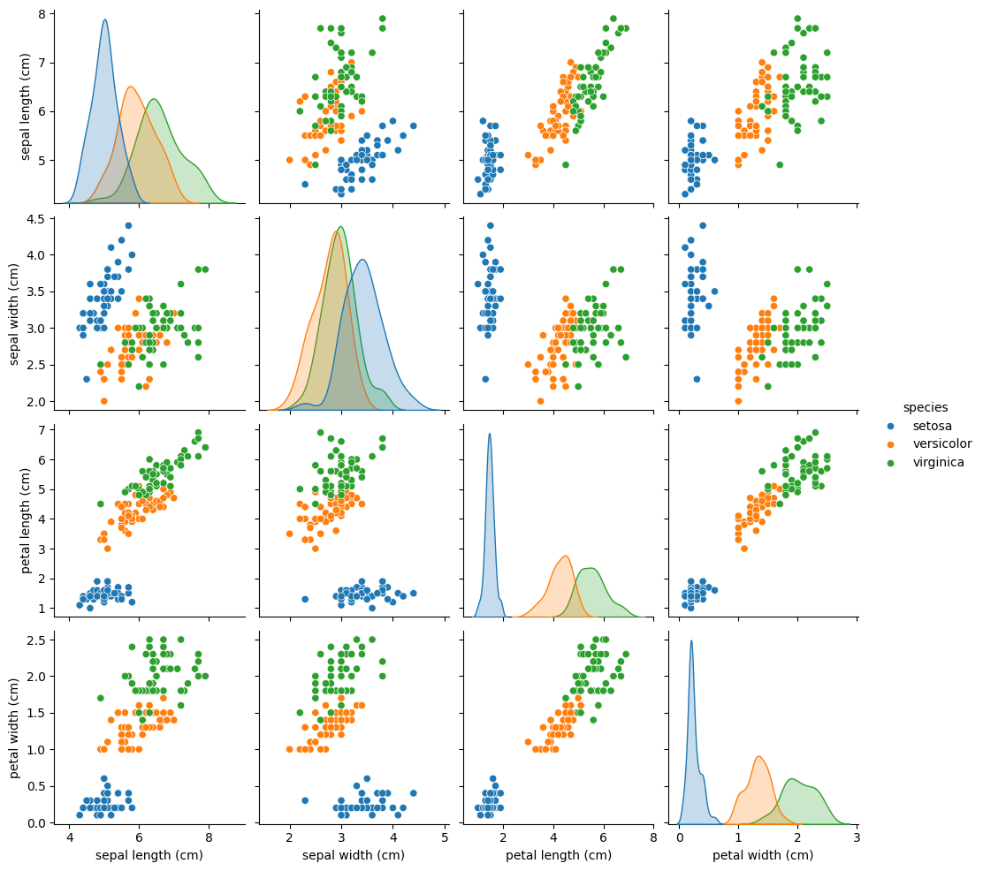

Q.NO.2:
The main difference between Multinomial Naive Bayes (MNB) and Gaussian Naive Bayes (GNB) classifiers lies in the type of data they are designed to handle and the underlying assumptions about the data distribution.

Multinomial Naive Bayes (MNB)
- Data Type: Primarily used for discrete data, especially for text classification (e.g., bag-of-words model).
- Assumption: Assumes that features (like word counts or frequencies) follow a multinomial distribution. It's suitable for datasets where features represent counts or frequencies.
- Use Cases: Commonly used in document classification, spam detection, and other applications where the data is represented as discrete counts.

Gaussian Naive Bayes (GNB)
- Data Type: Used for continuous data.
- Assumption: Assumes that features follow a Gaussian (normal) distribution. It estimates the mean and variance for each feature for each class.
- Use Cases: Often applied in scenarios where the data can be assumed to be normally distributed, such as in medical diagnosis or when analyzing continuous features.

